Indigenous Day of Learning Registration (F22): Instructions
The Indigenous Day of Learning event is designed as a community learning opportunity for SLC employees and students. This document provides a quick summary of all the registration links for the virtual and the onsite sessions for Indigenous Day of Learning. We ask that you follow the instructions below to prepare for the event:
- Review the schedule (see below) and register for each session using the associated link.
- After you complete the registration, you will receive an email confirmation where you can “add” the event to your outlook calendar. This event will include the meeting link that will be used to host the virtual event. Hybrid sessions on October 26 will include both the virtual link and the onsite room location on Cornwall campus.
- This event is open to all employees and students across the three campuses.
- If you have any questions about the event, please contact IWKB@sl.on.ca
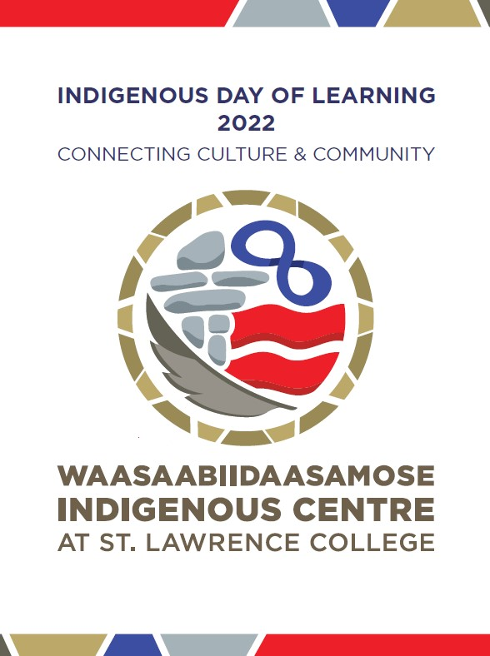
Picture 1. IDL Event Logo

DAY ONE - Tuesday, October 25, 2022 (Virtual)
Time | Session Title | Description | Facilitator | Meeting Link
8:30 -10:30 | Welcome to IDL Day 1 and Cultural Humility in Post-Secondary Education with Indigenous Students | In 2015 Universities Canada acknowledged that Indigenous students continue to be underrepresented in Canadian higher education institutions. The Truth and Reconciliation 94 Calls to Action has placed expectations upon post-secondary education institutions to do better and make change. Universities Canada response to closing the education gap between Indigenous and non-Indigenous people is with 13 principles which include developing opportunities for Indigenous students, providing supports and resources, Indigenizing the curricula, encouraging Indigenous leadership, providing welcoming respectful environments, accessibility, building partnerships, intercultural engagement, and promoting awareness of indigenous history. All of these efforts are to be commended, right? However, have they been effective? What more can post-secondary education institutions do to help indigenous students feel like they belong and have a place in post-secondary education?  As an Indigenous social worker who has worked in post-secondary education, healthcare and private practice I would suggest that the missing piece behind these initiatives is cultural humility. Fostering cultural humility encourages cultural safety. Cultural safety results in retention and success in post-secondary education. Rather than taking a reluctant or defensive stance towards equity, diversity and inclusivity; cultural humility encourages a willingness to be open, curious, and understand that cultural knowledge is not finite or something to master but rather an on-going process. This session will promote a shift from “othering” towards looking at ourselves and cultivating cultural humility. | Shannon Hall  Patrick Hymus  Mary Ann Lyons  Wendy Johnson | REGISTER
10:30-11:30 | Tyendinaga 101 | Link in and tune in for an hour and learn about your neighbors from Tyendinaga Mohawk Territory. We are only 45 minutes away physically, learn about our true history and some legends that formed Tyendinaga. Find out what makes us unique, let’s bust some myths together and find out our true narrative so we may begin to build a true historical consciousness. | Holly Brant | REGISTER
12:30-1:30 | How to Write a Land Acknowledgement | The purpose of this workshop is to explore the purpose of land acknowledgements and for all staff, students, administrators to develop a land acknowledgement. | Shannon Hall  Ross McMillan | REGISTER
1:30-3:00 | From Soundcloud to Standing Rock: A personal journey Decolonizing & Rematriating | Please join us as Dioganhdih (dee-yo-gaan-dee) shares their journey as an Indigenous two spirit artist decolonizing and rematriating through art, frontline action, and agriculture. | Diogandih | REGISTER
3:30-4:00 | Connect and Reflect | An opportunity to connect and reflect on the day | Shannon Hall | REGISTER

DAY TWO - Wednesday, October 26, 2022 (Virtual & Cornwall)
The second day of IDL will include a hybrid format with guest speakers on the Cornwall campus. Participants are welcome to participate onsite by attending the session in person or attend virtually using the link.
Time | Session Title | Description | Facilitator | Meeting Link
8:30-10:00 | Welcome to IDL Day 2 and Keynote Speaker - Elder Peter Garrow | Peter Garrow continues to be a strong advocate for the rights of First Nations people, their concept of life long learning and promoter of our people’s contributions to society and the world. Peter is a member of the Mohawks of Akwesasne – Bear Clan and has recently retired for the 4th time, the latest as the Manager for Entewatatha;wi/Nation Building for Mohawk Council of Akwesasne in the development of self - government agreements with Canada. Prior to this assignment, Peter was the Director of Education, Jurisdiction, Governance and Languages for the Assembly of First Nations (AFN) for 6 years and before this position he was the Director of Education for the Ahkwesahsne Mohawk Board of Education (AMBE) for 8 years. Peter was also a Board Member of the Board of Directors of the Ontario Public School Boards Association and chair the Native Trustees Council for 10 years. He has held senior executive positions within the Federal government in Ottawa and the Atlantic Region. Peter was also a Board Member of the Canadian Lacrosse Association and the Canadian Lacrosse Foundation and he is a member of the Akwesasne Lacrosse Hall of Fame. From 1964 to 1967 Peter served with the US. Air Force – 3 years in Germany.  As AFN Director, Peter was responsible for the AFN Chiefs in Assembly endorsing new policies for the education of our learners and as Director of Education for AMBE, Peter and his team helped established Akwesasne as one of the most successful education systems in North America.  Peter continues as a champion for causes such as “Shannen’s Dream”, “Jordan’s Principle” and the promotion and implementation of United Nations Declaration of Rights of Indigenous Peoples” and the continued research into the infamous Doctrine of Discovery. In April/2012 Peter was awarded Queen Elizabeth II Diamond Jubilee Medal for his work in advancing education and the rights of First Nation People in Canada. In 2014 Peter was the recipient of the Rotary International Paul Harris Award for building strong community relations. In May 2017, Peter was the recipient of an Honorary Diploma by the Board of Governors of St. Lawrence College for his continuing work on Indigenous Education for all students. Peter is married to his wife Harriet (Mohawk -Turtle Clan) for 53 years and they have three sons, Nathaniel, Christian and Garrison (all Turtle Clan). | Shannon Hall  Patrick Hymus  Pater Garrow | REGISTER
10:30- 12:30 | Treaty Talk - Origins of the Indigenous/White Councils | This session is about the principles, purposes, and origin of treaties. Kanathohare (Ga-nah-dough-ha-le) will discuss how treaties influenced the world, share principles and how they provided the foundation for mutual relationships, and how later treaties betrayed Indigenous people. | Mike Mcdonald | REGISTER
1:30 – 2:30 | Translating Haudenosaunee worldviews through Traditional Attire | Join Kakwireiosta-(gug-wee-lee-yo-sta) as she shares her journey of empowerment to rebuild, reconnect & revitalize cultural competency for her and her family through the making of traditional Haudenosaunee attire | Kakwireiosta | REGISTER
3:30 – 4:00 | Connect and Reflect | An opportunity to connect and reflect on the day | Shannon Hall | REGISTER

DAY TWO (Special Sessions) - Wednesday, October 26, 2022 (Cornwall)
We will be hosting two onsite sessions that will require specific registration caps due to the nature of the session and the resource materials required to facilitate the experience. Participants may showcase their interest to participate in these smaller sessions by submitting their name to a random draw.
Please submit your name before Wednesday October 19 at noon if you want to be considered for this learning opportunity. The full list of participants will be confirmed later that day after we complete the random draw.
Time | Session Title | Description | Facilitator | Submit
2:40 – 3:30 | Inukshuk Teachings | Join me in this interactive session as we build, share & learn some introductory history, culture, and facts about our northern brothers & sisters the Inuit. Leave the session with your own Inukshuk as we discuss specifically the meanings related to various types of Inuksuit. | Shirley Chaisson | Expression of Interest
9:00 -3:30 | Black Ash Basket Making | A hands-on opportunity anchored in both land-based and Haudenosaunee teachings/traditions while being led through the process of building your very own black ash basket. Participants will learn how cultural identity links Haudenosaunee people to the land and to a sustainable environment. | Glenn Swamp | Expression of Interest

